PROJECT: Final Network Design Report

VOORE. MANI SAI

Computer Networks/ Cyber security

PROF. Merrick Martin

March 04 ,2023

Introduction:

The Purpose of this study is to present a through network design strategy for company that incorporates all relevant enhancements and aligned with business goals objective. Which not only suggest the enhancement also improve the network security, performance to ensure the organization can track impact of these changes over time.

Final Network Design:

1. We are using segmentation concept for complex network resulting in prevention of unauthorized access. The internal network connects to server, database, and other devices. The external network will link to internet, DMZ will serve as a public access resources like web servers. We consider few points for implementing DMZ in Network Design:
   1. Monitoring: it is important to detect the security breaches by monitoring on going traffic. We can also use IDS and SIEM Solution which helps to find security information.
   2. Two-Firewall Approach: here we need to setup first firewall as a internet and second consider as a DMZ which can increase the security complexity of network and difficult to penetrate.
   3. Increased in security: For extra layer of security we need to isolate the public-facing resources.
2. For enhancing the security level, we use multi-factor authentication before accessing a system or application.
3. Conducting a scanning assessment for a network to now the potential network vulnerability.
4. Authentication Methods: Microsoft offers few security mechanisms which are:
   1. Windows Hello: this is mechanism where do facial recognition and pin verification.
   2. Azure Active Directory: This is functionality is used in for authenticate physical devices such as USB and smart card.
   3. Microsoft Authenticator: This generates a unique key for every 30 seconds which helps during the sign in account.

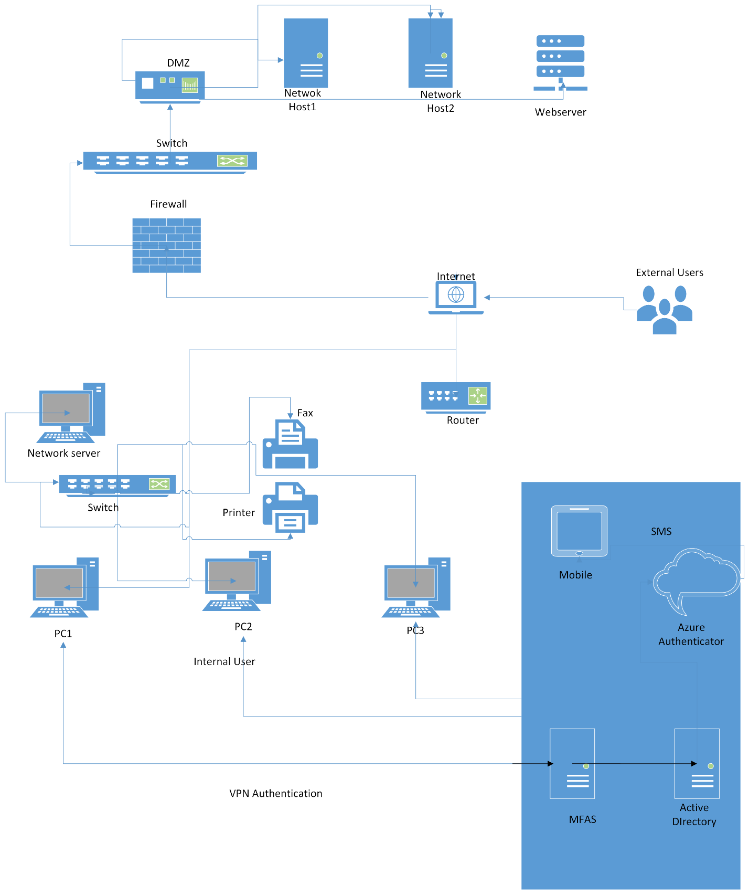

Professional Report:

The Report Provides a final network design and plan that combines all the related network enhancements. The final design aims to improve the overall performance of business needs and increase their network design, security, and performance.

As we approached the final stage, the proposed network design and plan includes all relevant enhancements to basic diagram. The aim of this report is to provide the proposed design, suggestion for measuring enhancement, persuade decision-makers to approach plan. The recommendations are presented in simple and clear language to ensure non-IT can understand.

The Network Enhancement will support organization further business needs by improving productivity, reducing cost, and maintain the on-premises servers. Below is the few major enhancement technique being for Network Design:

1. We need to integrate the cloud services for improving the data and make scalable such that it is easy to access.
2. For the network security we need to cop up with the latest protocol and technology to protect against attackers.
3. For high availability we need to breakdown the minimum time which can be done by implementing redundant network.
4. At last, for speed and capacity we need to every time the upgrade the bugs, patches, and loop poles.
5. For preventing unauthorized access and providing protection to network we need to use firewalls, intrusion detection and prevention systems, and access control mechanisms against cyber threats.
6. Improving in quality of service can be done by prioritizing traffic and ensure the critical application and services receives more bandwidth.
7. We need to implement the redundant topology for network to ensure the if component fails other will take a control automatically of a network.

Justification and Benefits:

Each Recommendation has been studied considered and ensure it aligns with organization business goals and objectives. The proposed enhancement will result in improve in network security, network performance, network reliability as well as productivity and collaborating between workers. For cost saving we integrate the cloud services.

Methods of measures:

To measure the success for each network enhancement metrics are:

1. Network Performance: for measuring the network performance we use tools and software to ensure an optimal result.
2. Network Availability: The measuring can be done by the monitoring tools which helps network to always up and running.
3. Security: We use scanning and penetration testing software to identify the weakness and potential threats.
4. Cloud Services: This can be measured by user feedback and adoption rate to identify the effectiveness of integration.

Conclusion:

The Network design is essential investment on infrastructure, redundant topology, securing, integrating the cloud services with network as improve the organization to remain the competitive in business landscape and benefits from performance, scalability, and availability. We urge the senior manager and other decision makers to approve the network design, plan and allocate all necessary resources to implement it.

# References

*Cisco Network Monitoring: 6 Best Practices*. (n.d.). Retrieved from MetricFire Blog: https://www.metricfire.com/blog/cisco-network-monitoring-6-best-practices/

*Guide to Enterprise Telework, Remote Access, and Bring Your Own ... - NIST*. (n.d.). Retrieved from nist: https://nvlpubs.nist.gov/nistpubs/SpecialPublications/NIST.SP.800-46r2.pdf

*Network Design and Architecture Best Practices*. (n.d.). Retrieved from IBM: https://www.ibm.com/cloud/learn/network-architecture-best-practices

*What is enterprise architecture? A framework for transformation*. (2022, November 23). Retrieved from CIO: https://www.cio.com/article/222421/what-is-enterprise-architecture-a-framework-for-transformation.html